Exercise 1 - Use Case Diagram

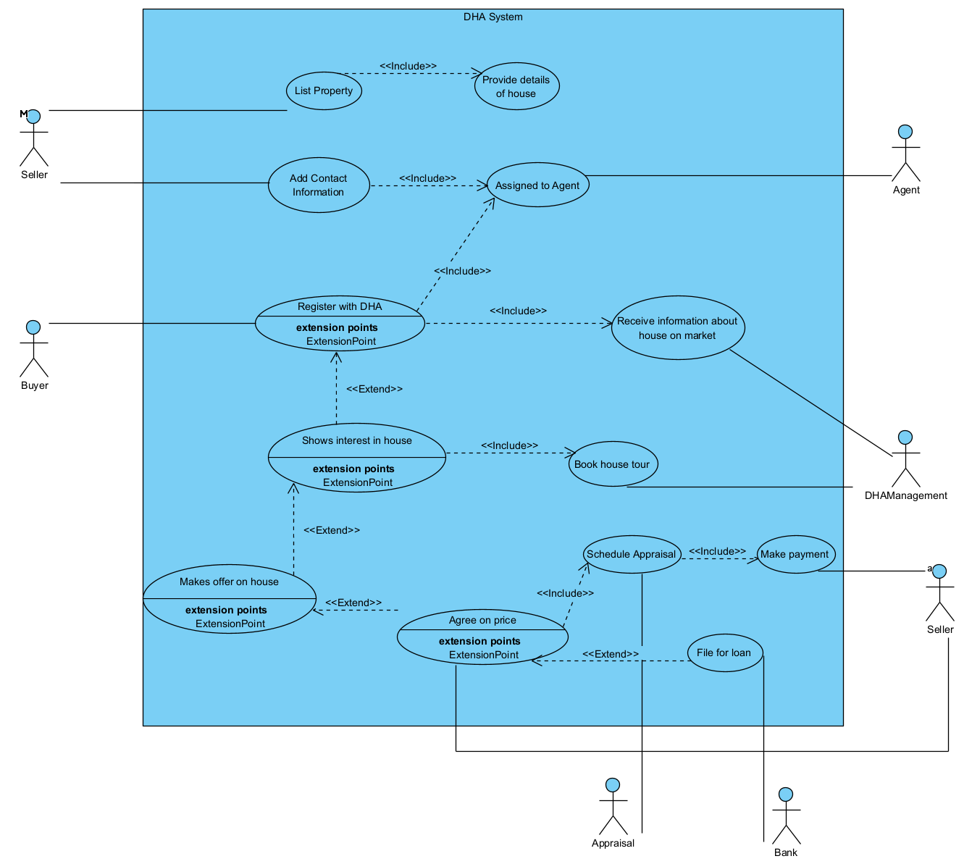

Exercise 2 - Class Diagram (simplified)

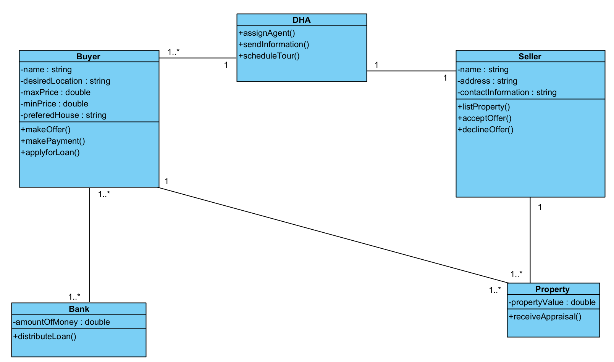

Exercise 3 - Sequence Diagram

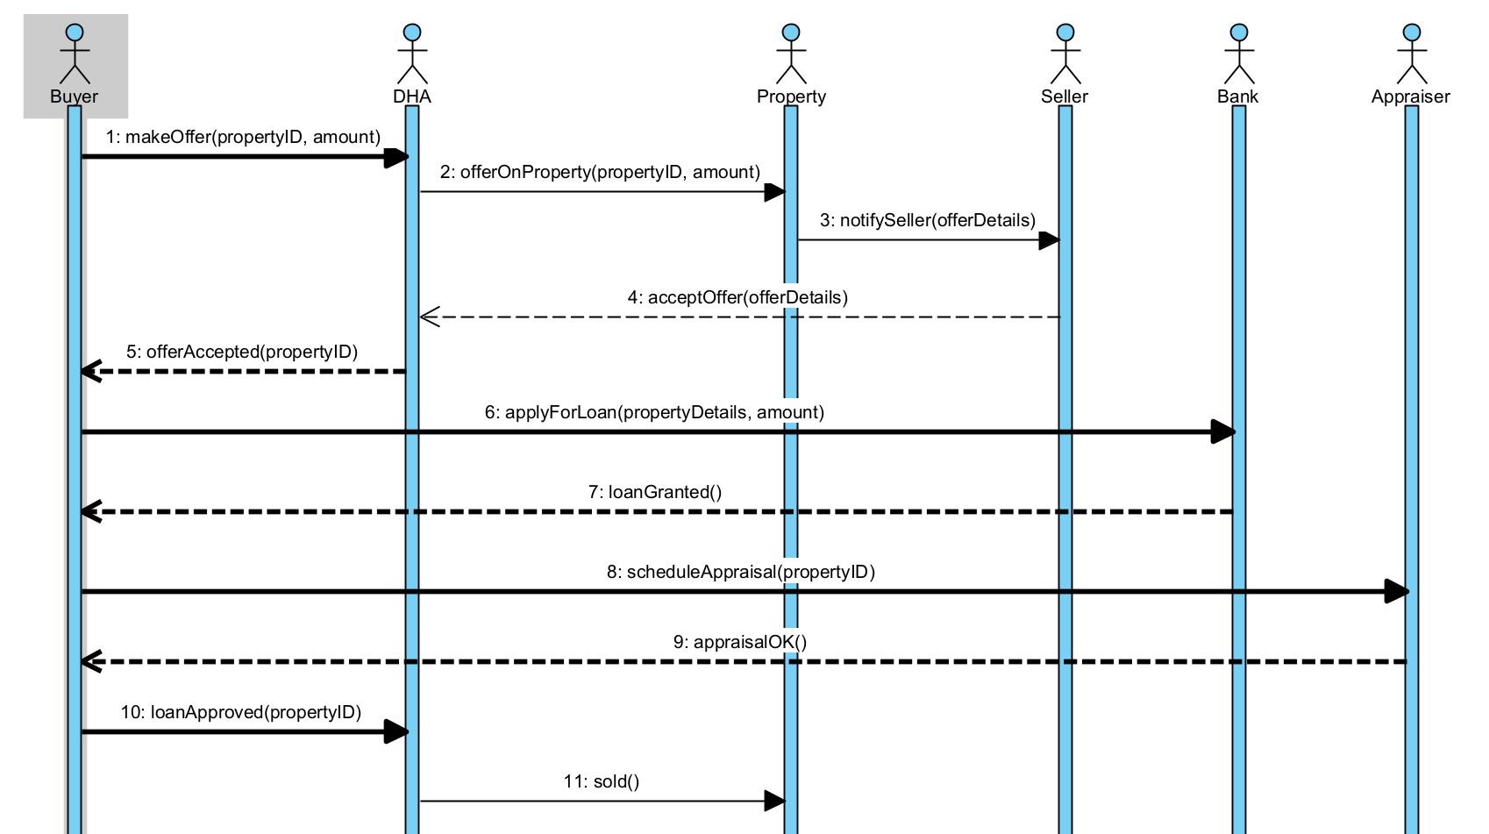

Exercise 4 -State Chart

